Ideation phase
Brainstorm & Idea Prioritization

Date | 27-12-2025
Team ID | SmartBridge – MERN stack batch 5497
Project Name | Bago (E-commerce)

Step-1: Brainstorm, Idea Listing
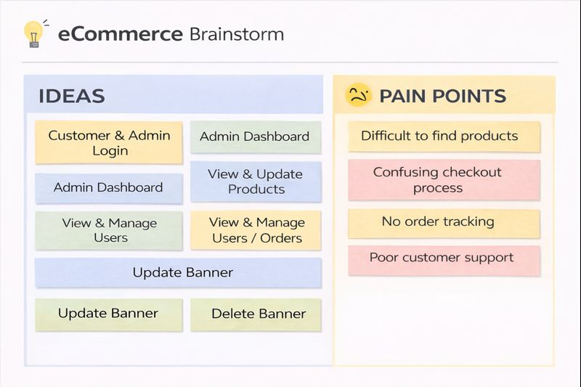

Step-2: Idea Prioritization
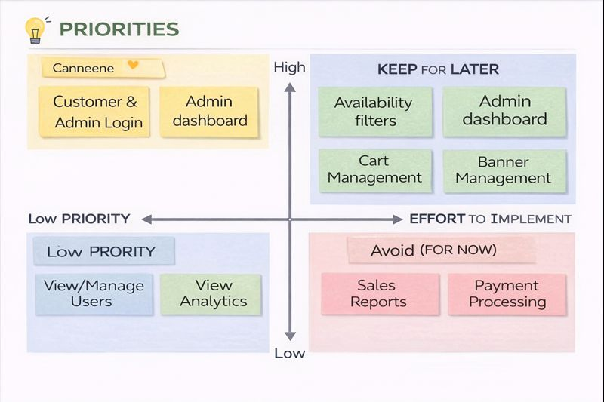
Step-3: Feature Prioritization (MoSCoW)
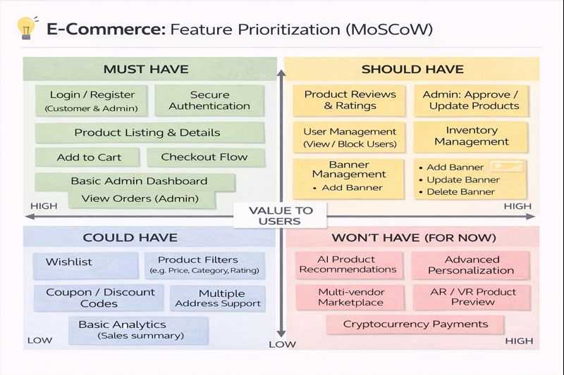

Step-4: Problem-Solutions
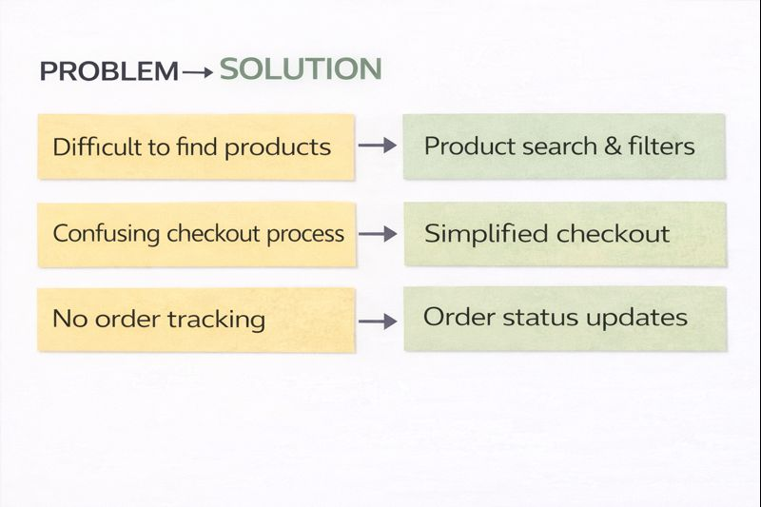

Step-5: Prioritized Roadmap
